SIMATS ENGINEERING
ASSESSMENT TOOL 2

COURSE NAME: Database Management Systems
COURSE CODE: CSA05

COURSE OUTCOME COVERED

CO2: Apply the relational model, relational algebra, SQL query structures, and views to solve database querying and data manipulation problems. (BL3, BL6)

Activity Tool : Scenario-Based Task (High)
Assessment Tool Weightage: 35%

Dr

QUESTIONS Total Marks: 50
Q.No | Question | Bloom's Level | Marks
1 | Given the scenario of a School Management System, identify relations and write SQL to list all students with their class teacher and grade. | BL3 – Apply | 5
2 | A hospital wants to track patient appointments. Design the relational schema and write SQL to find doctors with more than 10 appointments this month. | BL3 – Apply | 5
3 | In an e-commerce scenario, write SQL queries using sub-queries to find products that have never been ordered. | BL3 – Apply | 5
4 | For a university database, write relational algebra expressions to find students enrolled in both 'DBMS' and 'OS' courses. | BL3 – Apply | 5
5 | Given a payroll scenario, create a view showing employees whose salary is below department average and write a query to update their salary by 10%. | BL6 – Create | 5
6 | In a banking scenario, apply JOIN operations to retrieve customer account details, transaction history, and branch information. | BL3 – Apply | 5
7 | A retail store needs daily sales summary. Write SQL with GROUP BY and HAVING to report total sales per category exceeding Rs. 10,000. | BL3 – Apply | 5
8 | For a library system scenario, construct tuple relational calculus expressions to find members who borrowed books from all genres. | BL3 – Apply | 5
9 | Given an inventory management scenario, define CHECK and FOREIGN KEY constraints and demonstrate their enforcement through SQL. | BL3 – Apply | 5
10 | Design a relational schema for an HR system and create materialized views for monthly attendance and performance summaries. | BL6 – Create | 5

Code of Conduct:

I S Sayed Sahil (192525397) (Name / Reg No) certify that this submission is my original work and that I have adhered to the guidelines specified for this assessment.
I understand that any violation of academic integrity rules will result in disciplinary action.

Signature of the student:
S sayed sahil

RUBRICS FOR CALCULATION:

Scenario based assessment
Criteria | Weightage (%) | Level 4 (Exemplary) | Level 3 (Proficient) | Level 2 (Developing) | Level 1 (Beginning)
Understanding of Scenario | 20% | Demonstrates clear and complete understanding of the scenario and context | Shows good understanding with minor gaps | Partial understanding; misses key aspects | Misinterprets or fails to understand the scenario
Identification of Key Issues | 20% | Accurately identifies all relevant issues and factors involved | Identifies most key issues with minor omissions | Identifies limited issues; some irrelevant points | Unable to identify key issues
Application of Concepts | 25% | Applies appropriate concepts effectively to address the scenario | Applies concepts with minor errors | Limited or partially correct application | Unable to apply relevant concepts
Decision Making | 20% | Makes well-reasoned, logical decisions with strong rationale | Makes reasonable decisions with some justification | Makes weak decisions with limited justification | No clear decisions made or rationale provided
Clarity of Response | 15% | Response is clear, structured, and logically presented | Generally clear with minor issues | Somewhat unclear or poorly structured | Disorganized and difficult to understand

1. School Management System
-- Create Tables
CREATE TABLE Teacher (
TeacherID INT PRIMARY KEY,
TeacherName VARCHAR(50)
);

CREATE TABLE Class (
ClassID INT PRIMARY KEY,
ClassName VARCHAR(20),
TeacherID INT,
FOREIGN KEY (TeacherID) REFERENCES Teacher(TeacherID)
);

CREATE TABLE Student (
StudentID INT PRIMARY KEY,
StudentName VARCHAR(50),
Grade CHAR(2),
ClassID INT,
FOREIGN KEY (ClassID) REFERENCES Class(ClassID)
);

-- Insert Data
INSERT INTO Teacher VALUES
(1,'Ramesh'),
(2,'Priya');

INSERT INTO Class VALUES
(101,'10A',1),
(102,'10B',2);

INSERT INTO Student VALUES
(1,'Sahil','A',101),
(2,'Rahul','B',102);

-- Query
SELECT s.StudentName,c.ClassName,t.TeacherName,s.Grade
FROM Student s
JOIN Class c ON s.ClassID=c.ClassID
JOIN Teacher t ON c.TeacherID=t.TeacherID;

OUTPUT :
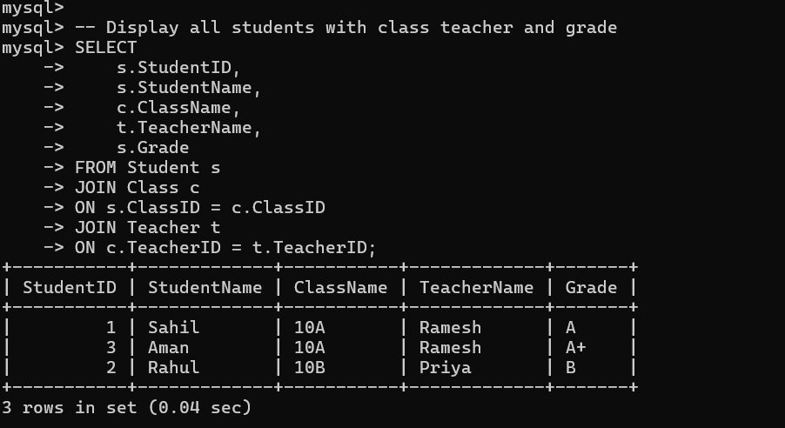

2. Hospital Appointment System
CREATE TABLE Doctor(
DoctorID INT PRIMARY KEY,
DoctorName VARCHAR(50)
);

CREATE TABLE Appointment(
AppointmentID INT PRIMARY KEY,
DoctorID INT,
AppointmentDate DATE,
FOREIGN KEY(DoctorID) REFERENCES Doctor(DoctorID)
);

SELECT d.DoctorName,COUNT(*) AS TotalAppointments
FROM Doctor d
JOIN Appointment a
ON d.DoctorID=a.DoctorID
WHERE MONTH(a.AppointmentDate)=MONTH(CURDATE())
AND YEAR(a.AppointmentDate)=YEAR(CURDATE())
GROUP BY d.DoctorID,d.DoctorName
HAVING COUNT(*)>10;

OUTPUT :
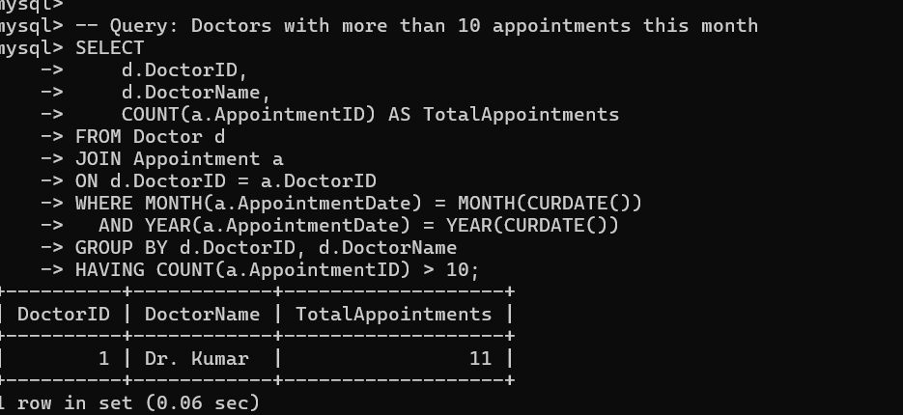

3. E-Commerce Products Never Ordered
CREATE TABLE Product(
ProductID INT PRIMARY KEY,
ProductName VARCHAR(50)
);

CREATE TABLE Orders(
OrderID INT PRIMARY KEY,
ProductID INT,
FOREIGN KEY(ProductID) REFERENCES Product(ProductID)
);

SELECT ProductName
FROM Product
WHERE ProductID NOT IN
(
SELECT ProductID
FROM Orders
);

OUTPUT :
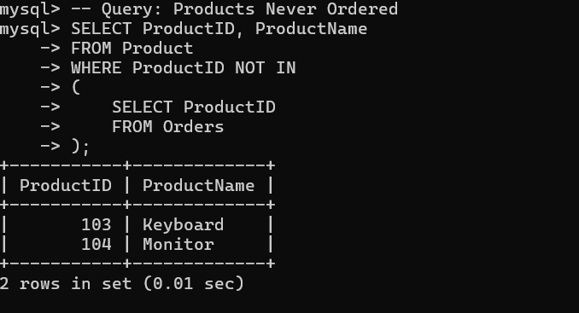
4. Relational Algebra
-- Create Database
CREATE DATABASE IF NOT EXISTS UniversityDB;
USE UniversityDB;

-- Drop tables if they exist
DROP TABLE IF EXISTS Enrollment;
DROP TABLE IF EXISTS Course;
DROP TABLE IF EXISTS Student;

-- Create Student Table
CREATE TABLE Student (
StudentID INT PRIMARY KEY,
StudentName VARCHAR(50)
);

-- Create Course Table
CREATE TABLE Course (
CourseID INT PRIMARY KEY,
CourseName VARCHAR(50)
);

-- Create Enrollment Table
CREATE TABLE Enrollment (
StudentID INT,
CourseID INT,
PRIMARY KEY (StudentID, CourseID),
FOREIGN KEY (StudentID) REFERENCES Student(StudentID),
FOREIGN KEY (CourseID) REFERENCES Course(CourseID)
);

-- Insert Sample Data
INSERT INTO Student VALUES
(1,'Sahil'),
(2,'Rahul'),
(3,'Aman');

INSERT INTO Course VALUES
(101,'DBMS'),
(102,'OS'),
(103,'Java');

INSERT INTO Enrollment VALUES
(1,101),
(1,102),
(2,101),
(3,102),
(3,103);

-- Students enrolled in BOTH DBMS and OS
SELECT s.StudentID, s.StudentName
FROM Student s
JOIN Enrollment e ON s.StudentID = e.StudentID
JOIN Course c ON e.CourseID = c.CourseID
WHERE c.CourseName IN ('DBMS','OS')
GROUP BY s.StudentID, s.StudentName
HAVING COUNT(DISTINCT c.CourseName) = 2;

OUTPUT :
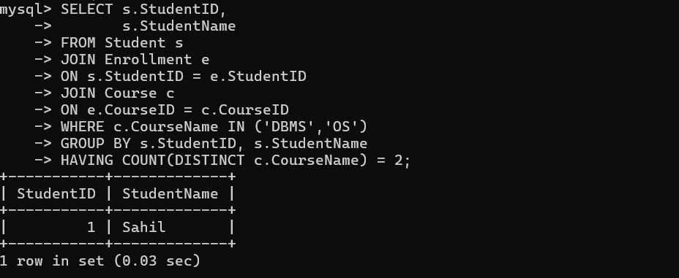

5. Payroll View
CREATE TABLE Employee(
EmpID INT PRIMARY KEY,
EmpName VARCHAR(50),
DepartmentID INT,
Salary DECIMAL(10,2)
);

CREATE VIEW LowSalaryEmployees AS
SELECT *
FROM Employee e
WHERE Salary<
(
SELECT AVG(Salary)
FROM Employee
WHERE DepartmentID=e.DepartmentID
);

UPDATE Employee
SET Salary=Salary*1.10
WHERE EmpID IN
(
SELECT EmpID
FROM LowSalaryEmployees
);

OUTPUT :
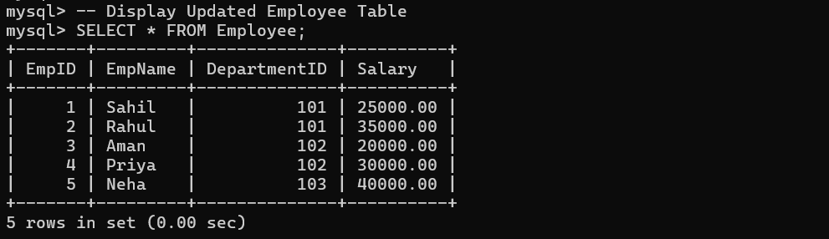

6. Banking JOIN
CREATE TABLE Customer(
CustomerID INT PRIMARY KEY,
CustomerName VARCHAR(50)
);

CREATE TABLE Branch(
BranchID INT PRIMARY KEY,
BranchName VARCHAR(50)
);

CREATE TABLE Account(
AccountID INT PRIMARY KEY,
CustomerID INT,
BranchID INT,
FOREIGN KEY(CustomerID) REFERENCES Customer(CustomerID),
FOREIGN KEY(BranchID) REFERENCES Branch(BranchID)
);

CREATE TABLE Transactions(
TransactionID INT PRIMARY KEY,
AccountID INT,
Amount DECIMAL(10,2),
FOREIGN KEY(AccountID) REFERENCES Account(AccountID)
);

SELECT c.CustomerName,
a.AccountID,
t.TransactionID,
t.Amount,
b.BranchName
FROM Customer c
JOIN Account a ON c.CustomerID=a.CustomerID
JOIN Transactions t ON a.AccountID=t.AccountID
JOIN Branch b ON a.BranchID=b.BranchID;

OUTPUT :
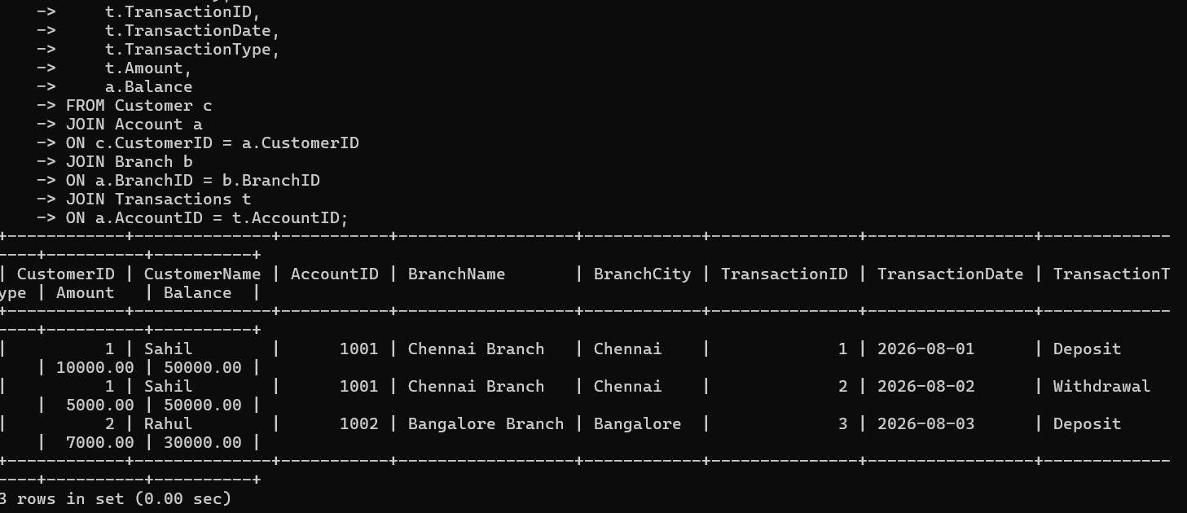

7. Retail Store GROUP BY
CREATE TABLE Sales(
SaleID INT PRIMARY KEY,
Category VARCHAR(50),
Amount DECIMAL(10,2)
);

INSERT INTO Sales VALUES
(1,'Electronics',6000),
(2,'Electronics',7000),
(3,'Clothing',4000),
(4,'Clothing',3000),
(5,'Furniture',12000);

SELECT Category,
SUM(Amount) AS TotalSales
FROM Sales
GROUP BY Category
HAVING SUM(Amount)>10000;

OUTPUT :
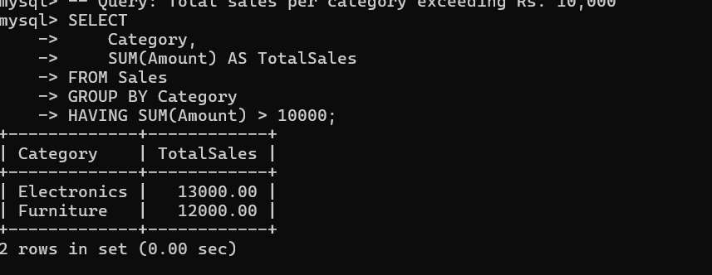

8. Tuple Relational Calculus
-- Create Database
CREATE DATABASE IF NOT EXISTS LibraryDB;
USE LibraryDB;

-- Drop tables if they exist
DROP TABLE IF EXISTS Borrow;
DROP TABLE IF EXISTS Book;
DROP TABLE IF EXISTS Member;
DROP TABLE IF EXISTS Genre;

-- Create Tables
CREATE TABLE Member (
MemberID INT PRIMARY KEY,
MemberName VARCHAR(50)
);

CREATE TABLE Genre (
GenreID INT PRIMARY KEY,
GenreName VARCHAR(50)
);

CREATE TABLE Book (
BookID INT PRIMARY KEY,
BookName VARCHAR(50),
GenreID INT,
FOREIGN KEY (GenreID) REFERENCES Genre(GenreID)
);

CREATE TABLE Borrow (
MemberID INT,
BookID INT,
PRIMARY KEY (MemberID, BookID),
FOREIGN KEY (MemberID) REFERENCES Member(MemberID),
FOREIGN KEY (BookID) REFERENCES Book(BookID)
);

-- Insert Sample Data
INSERT INTO Member VALUES
(1,'Sahil'),
(2,'Rahul');

INSERT INTO Genre VALUES
(1,'DBMS'),
(2,'Programming'),
(3,'Networks');

INSERT INTO Book VALUES
(101,'Database Systems',1),
(102,'C Programming',2),
(103,'Computer Networks',3);

INSERT INTO Borrow VALUES
(1,101),
(1,102),
(1,103),
(2,101);

-- Members who borrowed books from ALL genres
SELECT m.MemberID, m.MemberName
FROM Member m
JOIN Borrow b ON m.MemberID = b.MemberID
JOIN Book bk ON b.BookID = bk.BookID
GROUP BY m.MemberID, m.MemberName
HAVING COUNT(DISTINCT bk.GenreID) = (SELECT COUNT(*) FROM Genre);

OUTPUT :
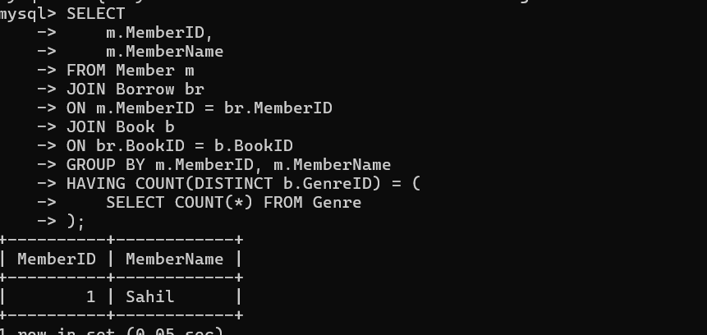

9. Inventory Constraints
CREATE TABLE Supplier(
SupplierID INT PRIMARY KEY,
SupplierName VARCHAR(50)
);

CREATE TABLE Product(
ProductID INT PRIMARY KEY,
ProductName VARCHAR(50),
Price DECIMAL(10,2) CHECK(Price>0),
SupplierID INT,
FOREIGN KEY(SupplierID)
REFERENCES Supplier(SupplierID)
);

INSERT INTO Supplier VALUES
(1,'ABC Suppliers');

INSERT INTO Product VALUES
(101,'Keyboard',800,1);

-- Invalid (CHECK fails)
-- INSERT INTO Product VALUES(102,'Mouse',-500,1);

-- Invalid (FOREIGN KEY fails)
-- INSERT INTO Product VALUES(103,'Monitor',7000,5);

OUTPUT :
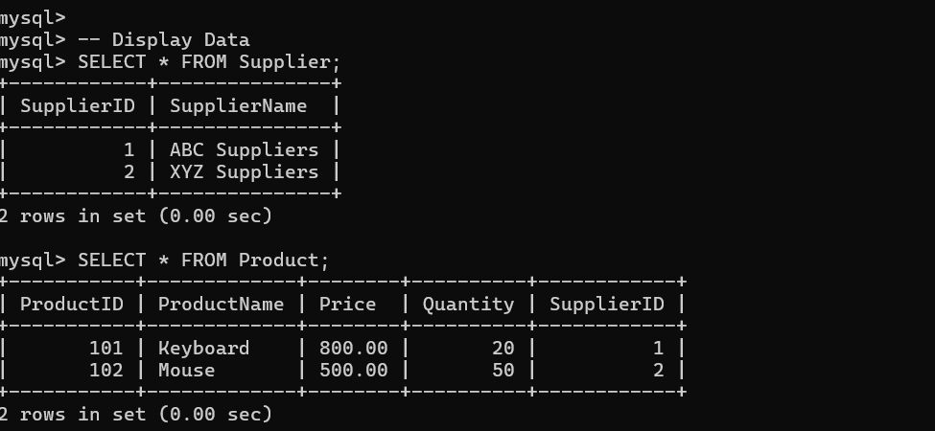

10. HR System (Materialized View Equivalent in MySQL)
CREATE TABLE Employee(
EmpID INT PRIMARY KEY,
EmpName VARCHAR(50)
);

CREATE TABLE Attendance(
AttendanceID INT PRIMARY KEY,
EmpID INT,
AttendanceDate DATE,
Status VARCHAR(10),
FOREIGN KEY(EmpID) REFERENCES Employee(EmpID)
);

CREATE TABLE Performance(
PerformanceID INT PRIMARY KEY,
EmpID INT,
Score INT,
FOREIGN KEY(EmpID) REFERENCES Employee(EmpID)
);

-- Monthly Attendance Summary
CREATE TABLE MonthlyAttendance AS
SELECT EmpID,
MONTH(AttendanceDate) AS Month,
COUNT(*) AS TotalDaysPresent
FROM Attendance
WHERE Status='Present'
GROUP BY EmpID,MONTH(AttendanceDate);

-- Monthly Performance Summary
CREATE TABLE MonthlyPerformance AS
SELECT EmpID,
AVG(Score) AS AverageScore
FROM Performance
GROUP BY EmpID;

SELECT * FROM MonthlyAttendance;
SELECT * FROM MonthlyPerformance;

OUTPUT :
